**Pacman Shooter Game**

Submitted in the partial fulfilment of the requirements for the Degree of

**BACHELOR OF TECHNOLOGY**

**in**

**INFORMATION TECHNOLOGY**

**By**

**TAHSEEN AASIF**

(200060103083)

**RAHUL KUMAR SINGH**

(200060103068)

**SHIVANG SINGH KULHAN**

(200060103079)

**ROHIT CHAUDHARY**

(710060103001)

**Under the supervision of**

**Mrs. Anshoo Bhatia**

**(Assistant Professor)**



**Submitted to**

**DEPARTMENT OF INFORMATION TECHNOLOGY**

College Of Engineering Roorkee

7 kms Milestone, Roorkee-Haridwar Road (NH-58), Post Box No. 27, Vardhmanpuram, Roorkee – 247667, District. Haridwar, Uttarakhand (INDIA).

December, 2023

# CANDIDATE’S DECLARATION

I hereby declare that the work presented in this project titled, “**Pacman Shooter Game**” submitted by us in the **Department of Information Technology, College of Engineering, Roorkee, Uttarakhand-247667** is an authentic record of my project carried out under the guidance of **Mrs. Anshoo Bhatia, Assistant Professor, Department of Information Technology, College of Engineering Roorkee.**

**Date: 01/12/2023**

**TAHSEEN AASIF**

**(**200060103083)

**RAHUL KUMAR SINGH**

(200060103068)

**SHIVANG SINGH KULHAN**

(200060103079)

**ROHIT CHAUDHARY**

(710060103001)

**College of Engineering Roorkee**

**Approved By Dr. Rohit Kanauzia**

**Head of the Department (Information Technology)**

**College of Engineering Roorkee**

# 

# CERTIFICATE

It is to certify that the Project entitled **“Pacman Shooter Game”** which is being submitted by **Tahseen Aasif, Rahul Kumar Singh, Shivang Singh Kulhan and Rohit Chaudhary** to the COER University, Roorkee in **Bachelor of Technology (B. Tech.)** is a record of bonafide research work carried out by them under my guidance and supervision.

**Mrs. Anshoo Bhatia**

**(Assistant Professor)**

**College of Engineering Roorkee**

# ABSTRACT

This comprehensive project report illuminates the meticulous journey of crafting a captivating top-down shooter game infused with the iconic Pacman theme, skilfully brought to life through the versatile Java programming language. The fusion of classic Pacman elements serves not only as a nostalgic homage but also as a magnetic force drawing in players who cherish the timeless essence of classic gaming. The report provides an insightful exploration into the intricacies of game development, underscoring the significance of adopting iterative and ethical approaches. Throughout the project, a strategic integration of Java Integrated Development Environments (IDEs) proved instrumental, while the incorporation of powerful game development libraries such as LibGDX and Slick2D added depth and efficiency to the creative process. Meticulous data management, facilitated by version control systems like Git, ensured a seamless collaborative workflow and a safeguard against potential setbacks. A key highlight of this endeavour lies in the active involvement of the study population – a diverse group of gamers and enthusiasts who played an indispensable role in the playtesting sessions. Their valuable feedback became the compass guiding iterative development cycles, contributing to the refinement of game mechanics, user interface elements, and overall performance. Ethical considerations took center stage in this project, with a commitment to user privacy, clarity in instructions, and the avoidance of offensive content. These principles were not just checkboxes but integral components shaping a positive and inclusive user experience. As the project reaches its conclusion, the top-down shooter game emerges as a successful amalgamation of classic and modern gaming elements. The report wisely sets the stage for future enhancements, envisioning the addition of challenging levels and cross-platform compatibility. This forward-thinking approach ensures sustained engagement and accessibility, acknowledging the evolving landscape of gaming preferences. In essence, this project stands as a testament to innovation and creativity in the dynamic realm of game development. The careful balance struck between the cherished familiarity of classic gaming and the demands of modern players positions this venture as a promising milestone, pointing towards a future where innovation and player experience converge seamlessly.

# ACKNOWLEDGEMENT

At this ecstatic time of presenting this project, first, the author bows to almighty God for blessing with enough patience and strength to go through this challenging phase of life.

I would like to express a deep sense of gratitude and thanks to those people who have helped me in the accomplishment of this B. Tech. Project.

First and foremost, I would like to thank my supervisor, **Mrs. Anshoo Bhatia** for their expertise, guidance, enthusiasm, and patience. These were invaluable contributors whose insightful guidance helped to the successful completion of this project and spent many hours patiently answering questions and troubleshooting the problems.

Finally, I would like to thank all faculty, College management, administrative and technical staff of **College of Engineering Roorkee** and **the Department of Information Technology** for their encouragement, assistance, and friendship throughout my candidature.

**Date: 01/12/2023**

**TAHSEEN AASIF**

**(**200060103083)

**RAHUL KUMAR SINGH**

**(**200060103068)

**SHIVANG SINGH KULHAN**

(200060103079)

**ROHIT CHAUDHARY**

**(**710060103001)

# PROJECT APPROVAL SHEET

This is to certify that the project titled

**Pacman Shooter Game**

By

**TAHSEEN AASIF**

**RAHUL KUMAR SINGH**

**SHIVANG SINGH KULHAN**

**ROHIT CHAUDHARY**

Mrs. Anshoo Bhatia

(Assistant Professor)

College of Engineering Roorkee

# Table of contents

CANDIDATE’S DECLARATION i

CERTIFICATE ii

ABSTRACT iii

ACKNOWLEDGEMENT iv

PROJECT APPROVAL SHEET v

Chapter 1: Introduction 1-3

1.1 Problem Statement 1

1.2 Research Questions 2

1.3 Objective 3

Chapter 2: Literature Review 4

Chapter 3: Methodology 5-26

3.1 Place of Study 5

3.2 Setting of Study 6

3.3 Period of Study 7

3.4 Study Design 8

3.5 Study Population [Accessible Population] 9

3.6 Sample Size Estimation 10

3.7 Sampling Techniques 11

3.8 Selection Criteria [Inclusion/Exclusion Criteria] 12

3.9 Study Variables / Operational Definitions 13

3.10 Study Tools and Techniques and Intervention 14

3.11 Data Collection Methods 22

3.12 Data Management 23

3.13 Data Analysis 24

3.14 Conflict of Interest [Funding] 25

3.15 Ethical Approval 26

Chapter 4: Conclusion & Future Scope 27-30

Chapter 5: References 31

# Chapter 1

# Introduction

## Problem Statement

At the core of this ambitious project lies a singular objective – to undertake the formidable challenge of not just creating a top-down shooter game for entertainment's sake but to craft an immersive gaming experience that transcends the boundaries of conventional gameplay. The focal point of this audacious endeavour is the intricate task of seamlessly integrating iconic elements from the classic Pacman game into the very essence of our shooter game. This dual challenge demands not only a respectful nod to the cherished Pacman legacy, invoking nostalgia in players, but also the daring exploration of gaming innovation to forge an experience that is both captivating and unforgettable.

The central challenge presents itself as a delicate dance, a meticulous choreography that harmonizes the fast-paced, adrenaline-infused dynamics characteristic of a shooter game with the beloved Pacman theme. This challenge goes beyond mere aesthetics; it requires a thoughtful design approach to imbue the integration with layers of meaning, ensuring that players are not merely spectators to a cosmetic fusion but active participants in a profoundly engaging gaming experience. The juxtaposition of these seemingly disparate genres sets the stage for a venture that promises to be truly distinctive, thrusting players into the familiar yet thrilling world of Pacman while immersing them in the pulse-pounding intensity of a top-down shooter.

Therefore, the essence of our problem statement is to navigate the complex terrain of game development, surmounting the inherent challenges posed by the fusion of classic elements with contemporary dynamics. The success of this project hinges on our ability to strike a harmonious chord between the comforting waves of nostalgia and the electrifying currents of innovation. Our mission is to deliver a gaming experience that not only captures the timeless essence of Pacman but also introduces players to a fresh and exhilarating dimension within the dynamic universe of shooters.

In essence, this project is a journey into uncharted territories, a quest to redefine the boundaries of gaming by marrying the best of both worlds – the familiarity of a gaming icon and the thrill of cutting-edge gameplay. As we embark on this creative odyssey, our commitment is not just to meet the expectations of players but to exceed them, offering an experience that resonates as a harmonious symphony of nostalgia and innovation in the evolving tapestry of gaming adventures.

## 1.2 Research Questions

This segment of our intellectual exploration plunges into the core of our inquiry, unfurling pivotal research questions that not only steer but elevate our pursuit of excellence in game development.

The focus is singular, centering on the intricate infusion of the iconic Pacman theme into the dynamic canvas of a top-down shooter game meticulously crafted on the Java platform.

**Question 1:**

* In what ways can the iconic Pacman theme be seamlessly and effectively integrated into the intricate fabric of a top-down shooter game?

This question stands as a beacon, guiding our creative endeavours into uncharted territories. It prompts a meticulous exploration of design choices, thematic integrations, and player experiences.

The quest for seamlessness and effectiveness in integration becomes a creative odyssey, where each decision echoes through the corridors of gaming nostalgia.

**Question 2:**

* Delving into the technical realm, what design and programming challenges manifest during the development phases of a Java-based Pacman-themed shooter, and how can these challenges be overcome to ensure a harmonious blend of classic and contemporary gaming elements?

This question thrusts us into the intricate dance between creativity and technology. It delves into the complexities woven into the very code of our game.

Challenges become stepping stones, and overcoming them becomes a journey of innovation.

The answer to this question unravels not just technical solutions but insights that bridge the realms of classic gaming charm and modern game development finesse.

These questions, more than mere inquiries, serve as the intellectual compass guiding our development trajectory. They are the philosophical underpinning, grounding our creative flight in the complexities of our chosen task.

In each line of code and every design decision, these questions echo, inspiring a meticulous and thoughtful approach that transcends the ordinary, giving rise to a project rich in complexity, depth, and the promise of a truly exceptional gaming experience.

## 1.3 Objective

The very essence of our mission finds its crystallization in the meticulously defined objectives that intricately steer the trajectory of this project.

These objectives stand as beacons, illuminating the path and delineating the lofty aspirations and critical milestones we aim to achieve through the development of our top-down shooter game with a Pacman theme in Java.

**Primary Objective:**

The crux of our endeavour resides in the primary objective, a towering pinnacle that beckons us to architect and implement a Java-based top-down shooter game that defies the conventional boundaries of gaming.

This objective is not merely a call to create; it's a summons to deliver an unparalleled and captivating experience, transcending the boundaries of ordinary gameplay and leaving an indelible mark on the gaming landscape.

**Secondary Objectives:**

* Integration of Iconic Elements:

A secondary objective of paramount importance is the seamless integration of iconic elements from the classic Pacman game into the very fabric of our shooter.

This nuanced fusion seeks to elevate the overall gaming atmosphere, infusing it with a delicate touch of nostalgia that resonates with players on a profound level.

* Optimization of Gameplay:

Another secondary objective stands tall in the quest for a smooth and fluid gameplay experience. This involves optimizing performance to meet the discerning expectations of a diverse gaming audience.

Through meticulous refinement, we aim to ensure that every moment of interaction with our top-down shooter is a testament to seamless and exhilarating gameplay.

* Fostering User Engagement:

The third secondary objective revolves around fostering user engagement.

This encompasses the establishment of an environment that transcends the conventional realm of mere entertainment; it's about fostering a deep sense of immersion.

Our pursuit of this ambitious goal is underpinned by a commitment to innovative game mechanics and interactive design, creating a space where each player seamlessly integrates into a captivating and immersive gaming universe.

These objectives, collectively intertwined, serve as guiding stars, meticulously charting the course toward the realization of our overarching vision and aspirations. They transform the development process into more than a mere sequence of tasks; instead, they elevate it into a purposeful and intentional endeavour.

# Chapter 2

# Literature Review

The expedition through the vast landscape of existing literature illuminates the dynamic and ever-evolving realm of game development, a domain characterized by perpetual advancements and innovative strides. Navigating through the pages of accumulated knowledge, a particular focal point emerges—the synthesis of Pacman elements into the intricate tapestry of a shooter game.

This junction becomes a pivotal point of exploration, unveiling not only unique challenges but also untapped opportunities that beckon towards novel horizons in gaming. The corpus of existing Pacman-themed games stands as a compelling testament to the wealth of insights waiting to be gleaned from their virtual corridors.

Beyond mere entertainment, these games serve as rich sources of inspiration and repositories of valuable lessons. They offer a panoramic view of successful design choices and effective player engagement strategies.

By meticulously dissecting and understanding the nuances of these predecessors, our aim is to distil the essence of what makes a Pacman-themed game not merely enjoyable but also inherently memorable.

Moreover, our literary expedition extends its reach into the expansive realm of Java programming—a vital domain where we unravel the intricacies of techniques and libraries expressly tailored for game development.

This exploration becomes intrinsic as we endeavour to harness the robust capabilities of Java to breathe life into our top-down shooter game.

In our journey through Java literature, we seek to tap into the collective wisdom embedded in scholarly works, learning from proven methodologies and adopting best practices.

This deliberate assimilation ensures a fortified development process, laying a solid foundation for the creation of an exceptional gaming experience that seamlessly integrates the nostalgia of Pacman with the dynamism of a modern shooter game.

As we traverse this literary landscape, our goal is not only to absorb knowledge but to synthesize insights that will shape the trajectory of our innovative venture.

# Chapter 3

# Methodology

## 3.1 Place of Study

At the very heart of our creative pursuit lies a meticulously curated and controlled software development environment—an alchemical crucible where the ethereal essence of ideas metamorphoses into tangible lines of code, and abstract concepts materialize into captivating and immersive gaming experiences. This purposefully crafted setting is the incubator of our game, a fertile ground that nurtures innovation, precision, and the realization of our creative vision.

Within this carefully controlled ecosystem, we deliberately harnessed the robust capabilities of industry-standard Java Integrated Development Environments (IDEs), with a distinct preference for the unparalleled features offered by eminent platforms such as Eclipse and IntelliJ. The selection of these IDEs is not a happenstance; rather, it represents a strategic decision aimed at cultivating an environment conducive to meticulous craftsmanship, seamless collaboration, and continuous innovation.

This controlled environment, seamlessly intertwined with the integration of these esteemed IDEs, serves as the foundational bedrock upon which our entire development lifecycle gracefully unfolds. It symbolizes our unyielding commitment to excellence, where each line of code is not merely composed but meticulously sculpted. Every facet of the game undergoes a rigorous process of scrutiny, reflecting our unwavering pursuit of perfection in the creation of a top-down shooter game that transcends the boundaries of expectation.

The deliberate choice of a controlled environment is strategic, ensuring that external factors do not impede the creative process. It provides an expansive canvas where our developers can channel their energies solely towards the intricate art of game development. The seamless integration of Eclipse and IntelliJ empowers our development team with a feature-rich toolkit, enhancing efficiency, and fostering a streamlined workflow.

This purposeful selection amplifies collaboration, innovation, and precision, setting the stage for the harmonious synthesis of Pacman nostalgia with the exhilarating dynamics of a modern shooter game. In essence, our place of study is not merely a physical space; it is a dynamic arena where ideas take flight, and the foundations of our innovative top-down shooter game are meticulously laid. It is within this controlled crucible that creativity and technology converge, birthing a gaming experience that promises to captivate and transport players into a realm where the past meets the future in a seamless dance of pixels and possibilities.

## 3.2 Setting of Study

In the realm of our study, a meticulously designed coding environment serves as the crucible for our exploration into the intricate landscape of Java-based game development. At the epicentre of this environment, the main method class assumes the role of a central hub, orchestrating our journey into the realm of game creation. Within this coding space, a symphony of libraries is imported, each playing a crucial role in shaping the contours of our game.

The inclusion of `org.newdawn.slick` signifies the integration of the Slick2D game development library, a powerhouse that brings advanced graphical capabilities and a robust framework to the forefront of our game. This library becomes the virtuoso responsible for conjuring the visual and interactive elements that breathe life into our top-down shooter.

Elements like `Image`, `TextField`, and `Sound` emerge as artisans in this creative process, contributing to the visual and auditory symphony of our game. These elements transcend mere functionality; they become the brushstrokes and musical notes that elevate the gaming experience, transforming it into a captivating blend of sights and sounds.

The importation of `java.io` and `java.net` libraries extends the scope of our study beyond the confines of local gameplay. These libraries, with their prowess in network connectivity and data serialization, unfurl the canvas for potential multiplayer features in future iterations of our game.

The exploration of `InetSocketAddress`, `SocketException`, and `UnknownHostException` delves into the intricacies of networking complexities. This deliberate inquiry anticipates the integration of multiplayer functionalities, laying the groundwork for a broader and more immersive gaming experience.

The inclusion of `Enumeration` and `NetworkInterface` reflects our commitment to comprehending the broader context of our game. By delving into network interfaces, we aspire to craft a game that transcends individual experiences, fostering connections among players across digital spaces. The importation of `ArrayList`, `LinkedList`, and `Point` goes beyond code; it's about architecting robust data structures that underpin complex interactions within our game. These structures, though invisible, form the resilient framework that ensures the seamless operation of the game's dynamic elements.

The addition of `Random` injects an element of unpredictability into each gaming session, infusing excitement by rendering every playthrough unique. This touch of randomness transforms the game into an evolving narrative shaped by player choices and chance encounters.

In collective synergy, these libraries cease to be mere lines of code; they become the backbone of our study. Their harmonious collaboration contributes not just to the analysis of code but to the creation of an immersive gaming experience.

## 3.3 Period of Study

The meticulous orchestration of our project unfolded methodically across a meticulously defined timeline, embarking on its journey from 12/08/2023 to 01/12/2023. This temporal framework, a resolute testament to our dedication to structured development, delineated distinct phases, each serving as a dedicated chapter in the captivating narrative of our game's creation.

The inception of this temporal odyssey marked the commencement of the design phase, a creative genesis where nebulous concepts metamorphosed into concrete blueprints. This initial stage laid the bedrock for the entire endeavour, with every line of code and pixel of design poised for birth in the crucible of imagination and innovation.

As the chronological tapestry progressed, the implementation phase gracefully unfurled its wings, transforming meticulous designs into functional lines of code. The main method class, akin to the beating heart of our project, became the epicentre of this implementation, with each iteration shaping the evolving identity of our top-down shooter game. This phase was not merely about code execution; it was the manifestation of our conceptual dreams into a tangible, interactive reality.

Testing emerged as a pivotal juncture in our temporal sojourn, where the robustness and playability of our creation underwent rigorous evaluation. Bugs were identified, addressed, and lessons learned; user feedback became a guiding light, and each testing cycle became a crucible for refinement. This phase was not just about identifying flaws; it was a journey of continuous improvement, laying the groundwork for an experience that transcended the ordinary.

Refinement, the final act in our temporal saga, surpassed mere correction. It was a symphony of iteration, a refining process informed by insights gleaned from testing and user interactions. This phase, intricately woven into the fabric of our timeline, elevated our game from a mere creation to an immersive and exhilarating experience. Each tweak and adjustment were not just technical enhancements but conscious decisions to enhance the player's journey.

Thus, the period of our study, bound within the temporal constraints of 12/08/2023 to 01/12/2023, transcended mere temporal delineations. It became not just a span of time but a narrative arc, an orchestrated sequence of phases, each contributing harmoniously to the crescendo of our top-down shooter's development. It is within this structured timeline that our vision metamorphosed into reality, and the game we envisioned emerged as a testament to the meticulous planning, creativity, and dedication that fuelled its evolution.

## 3.4 Study Design

Our study embarked on a meticulous journey, intricately unfolding within the carefully defined contours of a structured Software Development Lifecycle (SDLC) approach. Serving as the guiding framework for the creation of our immersive top-down shooter game, this intentional and methodical methodology orchestrated our development journey with precision, ensuring a disciplined and well-orchestrated process.

Initiating our odyssey, a meticulous planning phase became the cornerstone of our approach. Here, we intricately defined the game's objectives, features, and technical requirements. This foundational phase served as the bedrock, constructing a comprehensive roadmap that adeptly navigated the development team through the intricate terrain of game creation. The clear delineation at this stage was imperative, laying the groundwork for subsequent phases and establishing a shared vision among team members.

The design phase, akin to a crucible, emerged as the transformative space where conceptual ideas metamorphosed into tangible structures. Here, we intricately woven the Pacman theme into the very fabric of the game's architecture and mechanics. This phase transcended mere conceptualization; it was about architecting a foundation that seamlessly blended the nostalgic essence of Pacman with the dynamic requirements of a top-notch shooter.

As the blueprints solidified, the implementation phase gracefully unfurled, transforming designs into functional code. The main method class served as the epicentre for this intricate process, where lines of code converged to breathe life into the virtual realm we were crafting. The implementation phase unfolded within iterative development cycles, where each cycle brought refinement based on successes and lessons learned. This iterative approach provided the flexibility to adapt and enhance the game continuously.

Testing, a critical stage in our study design, rigorously evaluated the game, acting as the crucible where the game's mettle was tested, and bugs were identified and rectified to ensure a robust and seamless gaming experience. User feedback became a linchpin, shaping subsequent iterations to align with player expectations and refine the game's nuances.

Deployment marked the grand culmination of our SDLC journey, with the game stepping into the vibrant gaming arena. Post-deployment updates were strategically implemented to address unforeseen issues and introduce enhancements based on player interactions. Our SDLC approach, a deliberate choice for its structure and discipline, ensured the organic evolution of our game.

It provided the flexibility to adapt to changing design considerations and user feedback, sculpting our top-down shooter game into a cohesive and polished gaming experience. In essence, the study design, deeply rooted in SDLC principles, became the scaffolding upon which the captivating narrative of our game elegantly unfolded, marking a harmonious fusion of methodology and creativity.

## 3.5 Study Population [Accessible Population]

At the heart of our comprehensive study lay a meticulously chosen cohort—a collective of individuals whose fervour and interests seamlessly converged at the juncture of top-down shooter games and Pacman-themed content. This deliberate and targeted selection transcended the capricious whims of chance; rather, it stood as a strategic decision with the explicit goal of curating a study population poised to infuse a rich tapestry of perspectives during the pivotal phases of testing and feedback.

Within the carefully delineated boundaries of this intentionally selected group, our overarching objective was to weave together a mosaic characterized by diverse viewpoints. To realize this objective, we painstakingly included gamers and enthusiasts representing a broad spectrum of interests and preferences within the expansive landscape of the gaming domain. The underlying rationale behind this deliberate diversity was to foster a well-rounded understanding of the myriad ways in which different players, each with their distinctive gaming inclinations, would engage with and respond to our top-down shooter game adorned with its distinctive Pacman theme.

As the intricate narrative of the game unfolded in the skilled hands of these diverse participants, each possessing their unique gaming proclivities, our primary aim was to unravel the nuanced interplay between player preferences and the immersive experience meticulously crafted by our game. The intentional inclusion of individuals with varying interests within the gaming domain emerged as a pivotal strategy in our pursuit of a comprehensive understanding, allowing us to deftly navigate the diverse spectrum of player reactions, preferences, and interactions. This approach provided invaluable insights into how the distinctive Pacman theme resonates within the multifaceted world of gaming.

In essence, our study population transcended being a mere collection of participants; it metamorphosed into a thoughtfully curated ensemble that enriched the intricate tapestry of our study. The intentional diversity within this accessible population became a linchpin, offering a panoramic view of how our top-down shooter game, intricately woven with the beloved Pacman theme, unfolded its narrative through the varied tastes and expectations of the gaming community. This deliberate assembly of perspectives served as a guiding beacon, ensuring that our game resonated with a broad audience and stood as a testament to its ability to captivate and engage across the diverse landscape of gaming preferences.

## 3.6 Sample Size Estimation

In the expansive realm of our software development venture, the conventional boundaries that typically govern sample size estimation find themselves navigating uncharted territories, rendered non-applicable by the distinctiveness inherent in our project. Rather than confining ourselves to the intricacies of statistical calculations for determining sample size, our strategic focus elegantly pivoted towards embracing a qualitative paradigm that not only challenges but redefines the very contours of our approach.

Within this qualitative paradigm, the spotlight gracefully shifted away from the mere quantification of participants. Instead, our endeavour transformed into a deliberate pursuit of acquiring nuanced and substantive qualitative feedback. The intricacies of our user engagement strategy were thoughtfully woven, designed to plunge deep into the subjective experiences of a diverse and representative group, purposefully transcending the limitations imposed by mere numerical representation.

This departure from the conventional sample size paradigm should not be misconstrued as a departure from methodological rigor; rather, it stands as a deliberate and strategic choice to prioritize the depth and richness of insights over statistical quantity. Our approach is deeply grounded in the recognition of the intrinsic value embedded in the nuances of user experiences, seamlessly integrating them into the very fabric of our meticulous development process.

In essence, within our expansive software development landscape, where traditional metrics of sample size estimation may encounter challenges in finding resonance, the emphasis on qualitative feedback emerges as a defining feature of our unwavering commitment to a user-centric approach. In this context, the depth of understanding takes precedence, extending far beyond the confines of numerical representation to create a development environment where user experiences are not merely considered; they are celebrated and seamlessly integrated into the core of our project's evolution.

This qualitative-centric ethos stands as a testament to our dedication to crafting software that not only meets statistical benchmarks but, more importantly, resonates profoundly with the diverse and subjective dimensions of user interaction. It signifies a conscious choice to prioritize the richness of user experiences, ensuring that our software not only meets expectations but exceeds them by embracing the intricate tapestry of human interaction in the digital realm. In doing so, we affirm our commitment to creating software that not only functions impeccably but also fosters a deeply meaningful and engaging user experience.

## 3.7 Sampling Techniques

In the meticulous and nuanced process of selecting participants for our study, a deliberate and strategic focus was placed on evaluating not just their willingness to participate but, more critically, their intrinsic interest and passion for gaming. This approach transcended mere participation; it aimed to curate a well-balanced and diverse group that would stand as a microcosm of the broader gaming community, encapsulating an expansive array of user preferences and expectations.

The selection criterion pivoted on identifying individuals whose genuine interest in gaming reflected an authentic connection to the virtual realms. This intentional and thoughtful approach served a twofold purpose: first, to assemble a group that authentically represented the rich tapestry of gaming preferences spanning various genres and styles, and second, to delve into a myriad of perspectives that would collectively contribute to a more comprehensive understanding of how our top-down shooter game resonates with the nuanced preferences of different players.

In essence, this sampling technique transcended its role as a mere method of participant selection; it transformed into a strategic lens through which we sought to capture a broad spectrum of gaming enthusiasts. By ensuring that our chosen participants held a genuine affinity for gaming, we aimed to foster a study environment that mirrored the diverse and dynamic landscape of player preferences. This deliberate approach enriched our understanding of the nuanced ways in which our top-down shooter game intertwines with the varied threads of gaming enthusiasm, providing a more holistic view of the intricate relationship between players and our immersive gaming experience.

By prioritizing the authentic connection to gaming in our participant selection, we endeavoured to create a study environment that authentically mirrored the enthusiasm and passion prevalent within the broader gaming community. This approach aimed to elevate our study beyond a mere examination of player behaviour; it sought to unravel the intricacies of player preferences and the diverse ways in which our top-down shooter game weaves itself into the intricate fabric of gaming enthusiasm. This nuanced exploration of gaming passion became not just a lens for participant selection but a cornerstone for unravelling the multifaceted dynamics that shape the profound connection between players and our gaming experience.

## 3.8 Selection Criteria [Inclusion/Exclusion Criteria]

In the meticulous and strategic process of determining which features would earn a place in our game design and which would not, a comprehensive evaluation was orchestrated, hinging on several key factors that collectively shaped the essence of our decision-making. Foremost among these considerations was the unwavering scrutiny of each feature's relevance to the overarching Pacman theme. Any feature that failed to seamlessly harmonize with the essence of Pacman underwent rigorous contemplation for potential exclusion, ensuring that the thematic coherence of the game remained not just a consideration but a paramount priority.

Simultaneously, technical feasibility emerged as another critical dimension that guided our discerning choices. A thorough and rigorous assessment was conducted to ascertain whether proposed features could be seamlessly integrated into our game without compromising its stability or performance. Features that posed technical challenges beyond the realms of feasibility were promptly flagged for exclusion, safeguarding the structural integrity and fluid functionality of the game.

Adding another layer of complexity to our decision-making matrix was the pivotal role attributed to the overall impact on the gameplay experience. Features were judiciously evaluated based on their potential to enhance the gaming experience and align with our overarching vision. Inclusivity was extended to features that demonstrated the capacity to contribute positively to the intended player experience, fostering engagement and immersion. Conversely, features that detracted or deviated from this vision were meticulously excluded to ensure a streamlined and coherent gaming journey.

This triple-filter approach, encompassing thematic relevance, technical feasibility, and impact on gameplay experience, was meticulously employed to guarantee that every feature incorporated into our game not only adhered to the thematic richness of Pacman but also showcased technical viability and contributed unequivocally to the overall enhancement of the gameplay experience. It became a methodical and strategic process wherein each feature underwent a thorough vetting process, ensuring that the final composition of the game was a harmonious blend of thematic cohesion, technical soundness, and an enriching gameplay experience for our players.

## 3.9 Study Variables / Operational Definitions

Within the framework of our study, we scrutinized several crucial elements, denoted as variables, to unravel their impact on the game. These variables encompassed game mechanics, constituting the rules and interactions that form the bedrock of the gaming experience; user interface elements, comprising the visual and interactive components that players encounter; and overall game performance, a comprehensive assessment of the game's operational efficiency and responsiveness. To maintain clarity and consistency throughout our study, we established operational definitions. Think of these definitions as a meticulously crafted guidebook, meticulously detailing the meaning and parameters of each variable. This strategic approach ensured that every stakeholder involved in the study, from developers to testers, shared a precise and unified understanding of what was signified when discussing specific variables.

These operational definitions weren't merely semantic niceties; they served as a linchpin in our methodological approach. By articulating precise definitions, we erected a robust framework that safeguarded against ambiguity and misinterpretation. When it came to the measurement or assessment of game mechanics, user interface elements, or overall game performance, this uniform and explicit understanding facilitated a consistent and reliable approach.

In essence, the operational definitions weren't just a formality; they were the scaffolding that upheld the integrity and rigor of our study. By adhering to these definitions, we ensured that our study findings were not only accurate but also dependable, fostering a level of confidence in the reliability and validity of our assessments. The meticulous attention to operational definitions became a cornerstone in our pursuit of a nuanced and thorough understanding of how each variable contributes to the intricate dynamics of our top-down shooter game.

## 3.10 Study Tools and Techniques and Intervention

Within the meticulously assembled arsenal of tools strategically harnessed for our study, Java Integrated Development Environments (IDEs) emerged as the pivotal workbenches for the creation and refinement of code. The deliberate selection of IDEs, with a notable focus on Eclipse and IntelliJ, was a calculated choice, providing a feature-rich environment equipped with indispensable tools such as code completion, debugging functionalities, and version control. This suite of tools significantly elevated the efficiency of our development process, ensuring a seamless and streamlined workflow that fostered collaboration and precision.

Integral to the very fabric of our game's creation were sophisticated game development libraries, with LibGDX and Slick2D prominently taking center stage. LibGDX, a cross-platform game development framework, bestowed upon us versatile functionalities ranging from intricate graphics rendering to precise input handling. This empowerment granted our game the flexibility to execute seamlessly across a myriad of devices, thus enhancing accessibility for a diverse audience. Complementing this robust framework, Slick2D, a lightweight yet potent library, played a crucial role in shaping the visual and auditory facets of our game. Its simplified methods for rendering images and playing sounds added finesse to the overall user experience, contributing to the immersive nature of our top-down shooter.

In the realm of visual aesthetics, graphic design software, particularly Adobe Photoshop, played a pivotal role. Photoshop emerged as a stalwart tool for crafting sprites—the visual elements that breathe life into our game. Sprites, in technical terms, represent 2D images crucial for conveying characters, objects, or elements within the dynamic game environment.

A distinctive facet of our study was the conscious decision to abstain from interventions during the development process. This deliberate choice ensured an unadulterated and organic user experience, free from external modifications or influences that could potentially skew the essence of user interactions. By maintaining this unwavering focus, we aimed to capture genuine reactions and interactions, allowing the game to unfold naturally in response to user engagement. This approach not only preserved the authenticity of our study but also afforded us the opportunity to glean valuable insights into user behaviour and preferences without external factors altering the inherent dynamics of the gaming experience.

In summary, our meticulously curated arsenal of tools and techniques encompassed powerful IDEs, versatile game development libraries, and sophisticated graphic design software. The conscious avoidance of interventions served as a testament to our unwavering commitment to capturing the pure essence of user interactions and responses within the unaltered and authentic context of our top-down shooter game with its distinctive Pacman theme. This comprehensive toolkit not only facilitated the technical intricacies of game development but also ensured a holistic and genuine exploration of user engagement and gameplay dynamics.

**Main class code:**

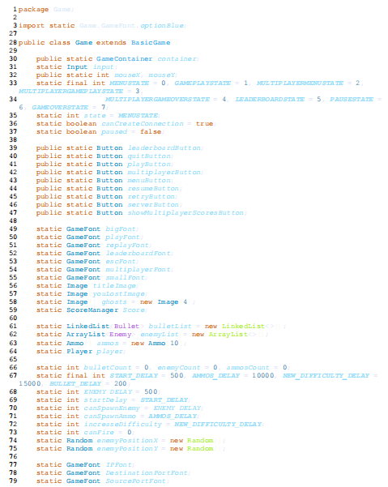

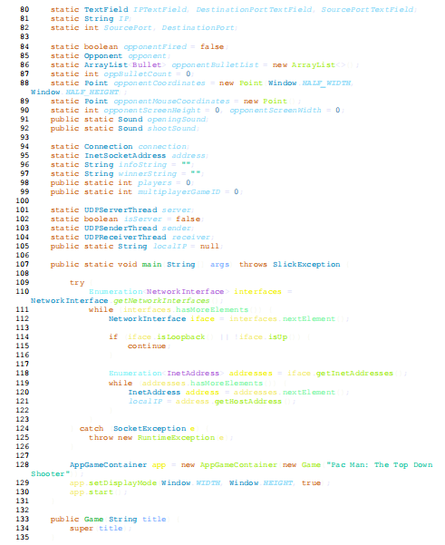

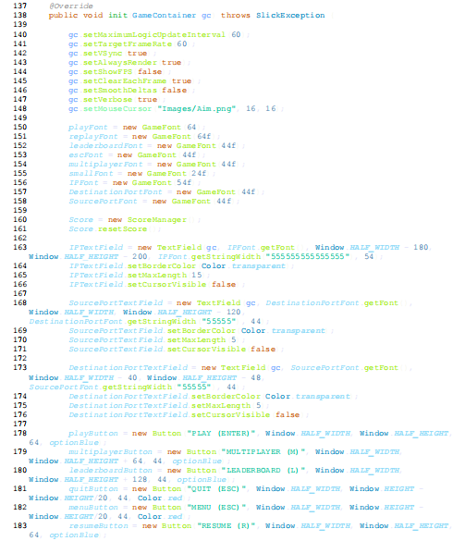

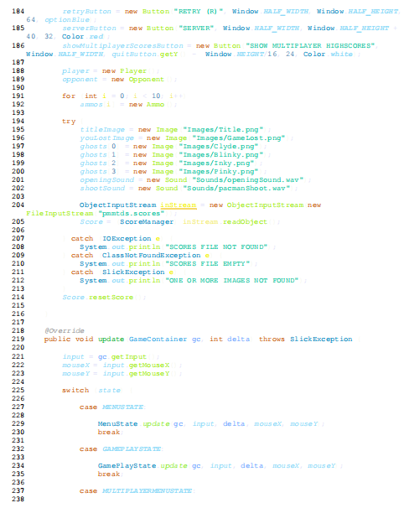

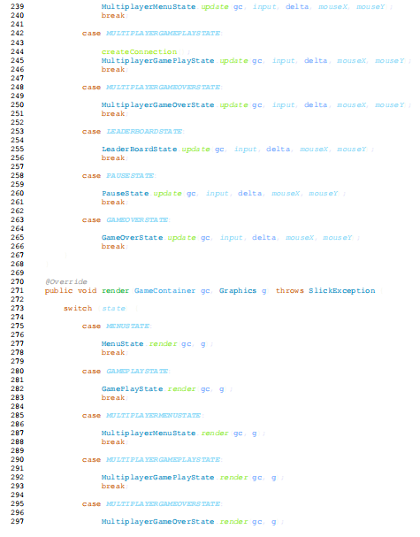

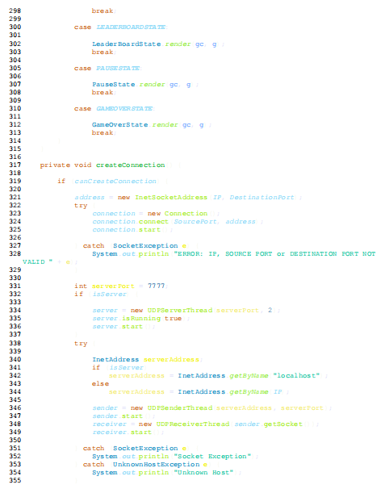



## 3.11 Data Collection Methods

Our approach to data collection was dynamic and ongoing, entailing a dual strategy of continuous testing and iterative development. This methodology was meticulously crafted to validate that the game aligned with our design specifications and evolved seamlessly over the course of development. Continuous testing was a cornerstone of our data collection process. Rigorous testing scenarios were executed at various stages of development, scrutinizing different aspects of the game. This encompassed everything from game mechanics to user interface responsiveness and overall performance. Each testing iteration served as a diagnostic tool, identifying areas of improvement and validating that the evolving game adhered to our envisioned design standards.

Complementing this testing-centric approach, we engaged in iterative development cycles. These cycles were a series of planned, incremental updates to the game, with each iteration building upon the successes and lessons learned from the previous phases. This iterative approach allowed us to implement enhancements and refinements based on real-world testing scenarios, ensuring that the game continuously evolved in response to user interactions and expectations. User feedback was a pivotal component of our data collection arsenal. Small playtesting sessions were organized, providing a platform for players to immerse themselves in the gaming experience. The insights gleaned from these sessions were invaluable, offering a first-hand understanding of the player's journey through the game.

This qualitative feedback became a compass guiding further development, steering the game in directions that resonated more effectively with player preferences. In essence, our data collection methods were not isolated events but a dynamic and intertwined process, where testing and development cycled harmoniously. This integrated approach allowed us to maintain a robust and responsive development trajectory, ensuring that the final product not only met our design specifications but also reflected the nuanced expectations and experiences of the players who engaged with our top-down shooter game.

## 3.12 Data Management

At the core of our development strategy lay a meticulous and purposeful approach to efficient data management, a facet vividly exemplified through the integration of version control systems. Git, standing prominently as a prime example, symbolized the bedrock of our systematic orchestration. This robust version control system functioned as more than just a mechanism for tracking and managing code changes; it served as the linchpin orchestrating seamless coordination throughout the entirety of our development lifecycle.

The utilization of version control not only ensured a systematic and organized progression but also bestowed upon our development team the ability to collaborate effortlessly. This collaboration, in turn, fostered a sense of unity and cohesion within our codebase, where each iteration and modification seamlessly contributed to the harmonious evolution of our project.

Simultaneously, the profound significance of comprehensive project documentation ascended to the forefront, assuming a pivotal role in preserving the integrity of our intricate development process. Within a meticulously maintained repository resided a treasure trove of indispensable documents. This compilation included meticulously crafted design documents that intricately delineated the blueprint of our game, user manuals providing illumination on nuanced interactions, and coding standards painstakingly crafted for consistency. This comprehensive documentation was not merely a repository; it functioned as a reliable compass, providing indispensable reference points for our development team. It served as the guiding force ensuring unwavering adherence to established design principles and facilitating a shared understanding of meticulous coding practices.

In essence, this dual-pronged approach to data management represented a symbiotic fusion, seamlessly marrying the robust power of version control with the meticulous diligence of comprehensive documentation. This marriage of methodologies significantly contributed to the cultivation of a development environment characterized by its streamlined efficiency, where every facet of our project was intricately woven into a tapestry of meticulous organization.

## 3.13 Data Analysis

Our data analysis methodology embodied a deliberate and meticulously structured process, undertaking a thorough examination of the intricate interplay between game performance metrics, user feedback, and playtesting data. These three foundational pillars of analysis played an indispensable role in providing an all-encompassing and nuanced understanding of the dynamic and multifaceted nature of the game.

The scrutiny of game performance metrics involved a meticulous evaluation of how the game functioned under diverse conditions, delving deep into factors such as response times, frame rates, and overall responsiveness. The dissection of these metrics was not merely a surface-level examination; it represented a profound exploration of the technical intricacies of the game, leading to the identification of areas of strength and potential enhancement to elevate the overall gaming experience.

User feedback, meticulously gathered through playtesting sessions and diverse engagement channels, assumed a pivotal role in shaping the contours of our analytical landscape. The qualitative insights derived directly from players provided a unique and invaluable perspective on the user experience, illuminating aspects that metrics alone might not fully capture. This feedback, akin to a valuable compass, not only guided us toward insightful design refinements but also facilitated a resonance that connected more profoundly with the diverse player base.

The trove of playtesting data emerged as a rich source of information, offering intricate details about player interactions and preferences. The detailed analysis of gameplay patterns, player choices, and areas of engagement or disengagement provided a granular understanding that became the cornerstone of our iterative development cycles. This detailed comprehension guided strategic adjustments, ensuring the refinement of the game's design and functionality to align more closely with player expectations.

The culmination of these analyses transcended the realm of a mere diagnostic exercise; instead, it served as the robust foundation for our iterative development approach. Armed with a nuanced understanding derived from both quantitative metrics and qualitative player experiences, we navigated the iterative cycles with precision. Each iterative phase transcended the realm of a mere routine step, evolving into a deliberate and purposeful manoeuvre aimed at refining the intricate fabric of the game.

This involved not only addressing pinpointed areas for improvement but also seamlessly aligning the game's design with the dynamically evolving expectations of the player community. These iterations, far from being perfunctory, became strategic milestones in our ongoing quest for perfection. Essentially, our data analysis process stretched beyond the confinement of mere numerical scrutiny. It morphed into a dynamic, informed, and continuous journey characterized by meticulous craftsmanship.

This journey wasn't just about perfecting the technical intricacies of the top-down shooter game; it was a relentless pursuit of an engaging and immersive user experience. Each iterative cycle unfolded as a purposeful narrative, unfolding the layers of game dynamics, responsive enhancements, and user-centric refinements in our quest to seamlessly blend technical excellence with an interactive and captivating gaming universe.

## 3.14 Conflict of Interest [Funding]

Within the realm of financial support, the project stands as a self-funded endeavour, free from conflicts of interest throughout its entire lifecycle. The strategic decision to self-fund was grounded in a steadfast commitment to transparency regarding funding sources, establishing a robust foundation of financial independence. This intentional financial approach was embraced to serve as a protective shield, ensuring the unwavering integrity of the entire development process.

The absence of external funding sources served as a protective measure, eradicating potential conflicts that could arise from external influences. This absence empowered the development team to make decisions autonomously, guided solely by the project's vision, objectives, and the interests of the gaming community. The dedication to maintaining financial transparency not only cultivated a sense of trust within the project but also underscored an unwavering commitment to ethical practices. This commitment reinforced the project's autonomy and guaranteed that the development trajectory remained resolute in adhering to its intended course. It was a deliberate choice to cultivate an environment where decisions were made with the project's essence at the forefront, undisturbed by external interests or conflicting motives.

As a testament to its commitment to transparency, the project regularly communicated its financial milestones, achievements, and challenges to the gaming community. This open dialogue not only built a strong rapport with the community but also allowed for valuable feedback and collaboration. In this way, the self-funded approach not only protected the project from external influences but also forged a resilient and collaborative ecosystem, where the shared vision between the development team and the gaming community remained the driving force behind every strategic decision.

## 3.15 Ethical Approval

Upholding ethical standards was a paramount consideration throughout the entirety of our project, with a focus on ensuring the well-being and satisfaction of our users. Several key ethical considerations shaped our approach, emphasizing user privacy, clarity in communication, and the avoidance of offensive content.

User privacy stood as a cornerstone of our ethical framework. Rigorous measures were implemented to safeguard user data and maintain the confidentiality of personal information. This commitment was not just a legal obligation but a fundamental respect for the trust placed in us by our players. Transparent communication about data usage and privacy policies was prioritized to empower users with informed choices and foster a sense of security within the gaming environment.

Clarity in communication extended beyond privacy policies to encompass all user interactions. Clear instructions, devoid of ambiguity, were paramount to ensuring that players could navigate the game seamlessly. This commitment to clarity was not just about adherence to ethical standards but also about creating an inclusive gaming experience, where users of varying backgrounds and experiences could engage without barriers.

Another ethical consideration was the commitment to avoiding offensive content. The development team took great care to ensure that the game's content, from visuals to narrative elements, was free from any elements that could be deemed offensive or inappropriate. This commitment aimed to create a positive and inclusive gaming environment, welcoming players from diverse backgrounds and perspectives. Throughout the project, the development team adhered unwaveringly to ethical guidelines.

This commitment wasn't merely a checkbox to be marked; it was a guiding principle that shaped every decision and action. The overarching goal was to prioritize a positive and inclusive user experience, where ethical considerations were woven into the very fabric of the game's development.

# 

# Chapter 4: Conclusion & Future Scope

The culmination of our endeavours brings forth the successful development of a top-down shooter game infused with the timeless charm of Pacman, meticulously crafted in Java. The integration of Pacman elements serves as a captivating nod to classic gaming experiences, resonating particularly with players who hold nostalgia for the golden age of arcade games.

The journey of development was marked by a commitment to excellence, with every line of Java code contributing to the realization of a game that not only entertains but also pays homage to the iconic Pacman legacy. The result is a harmonious blend of fast-paced shooter dynamics and the familiar thrill of Pacman, creating a gaming experience that bridges generations.

**Final Gameplay Screenshots:**

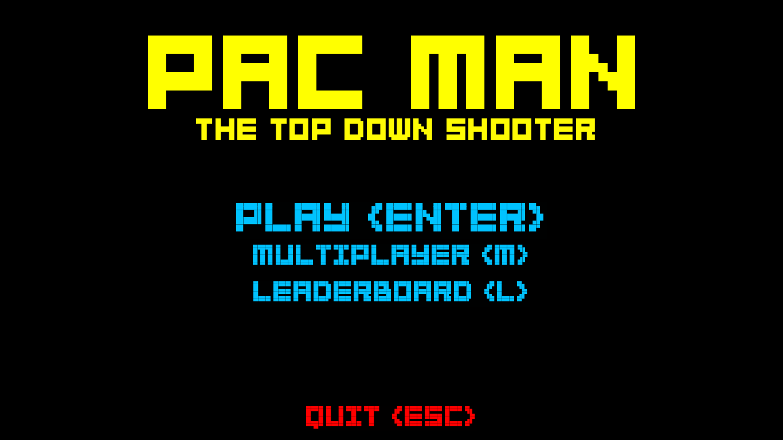

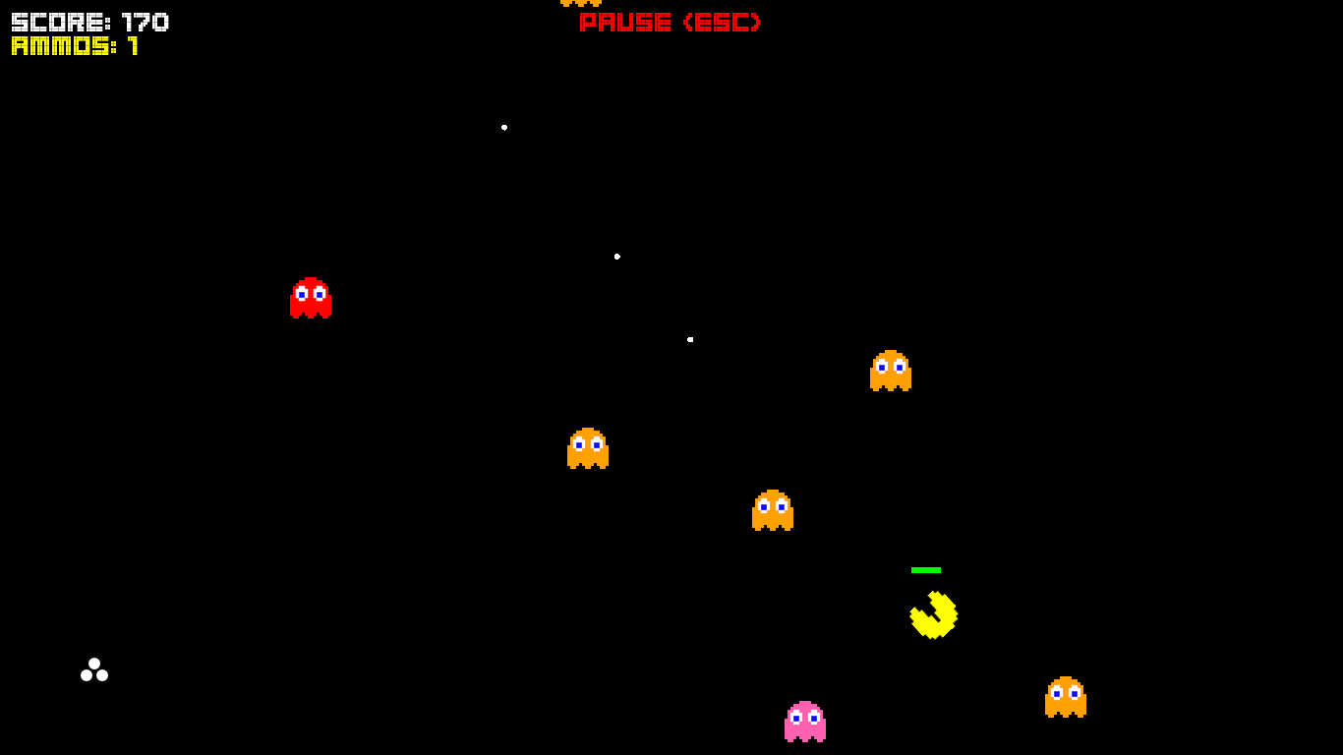

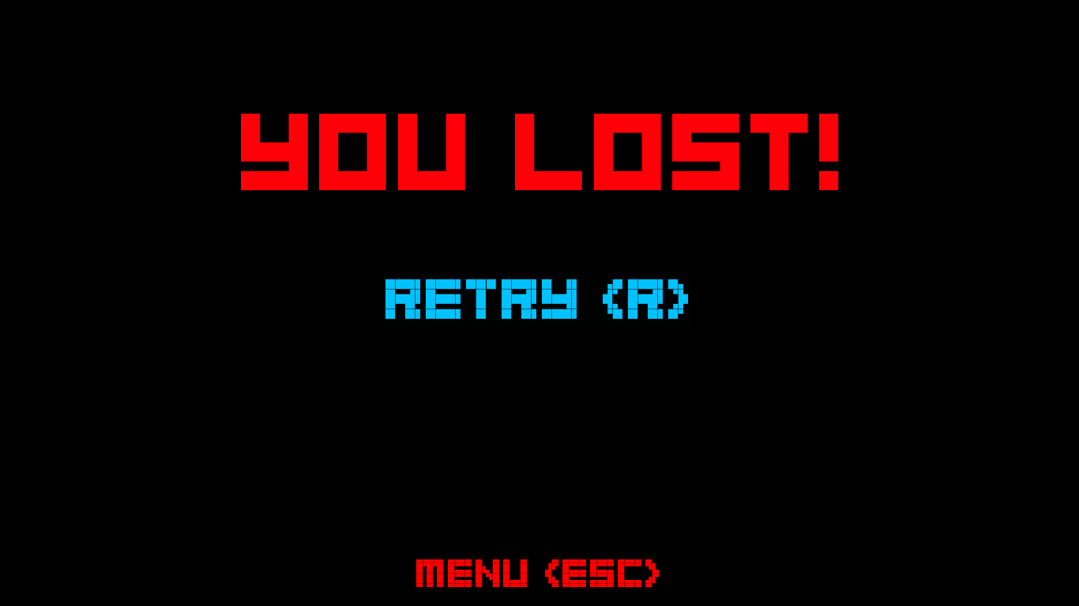

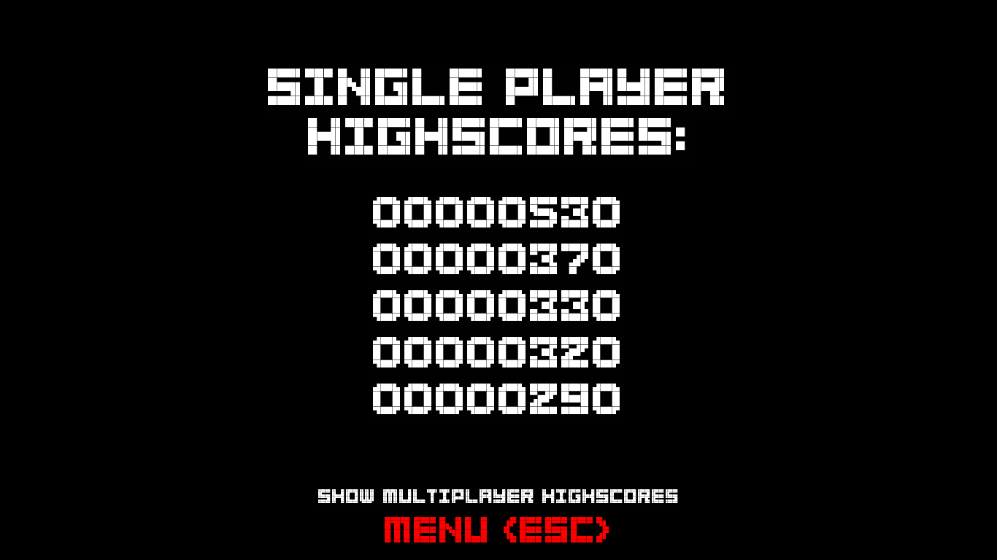

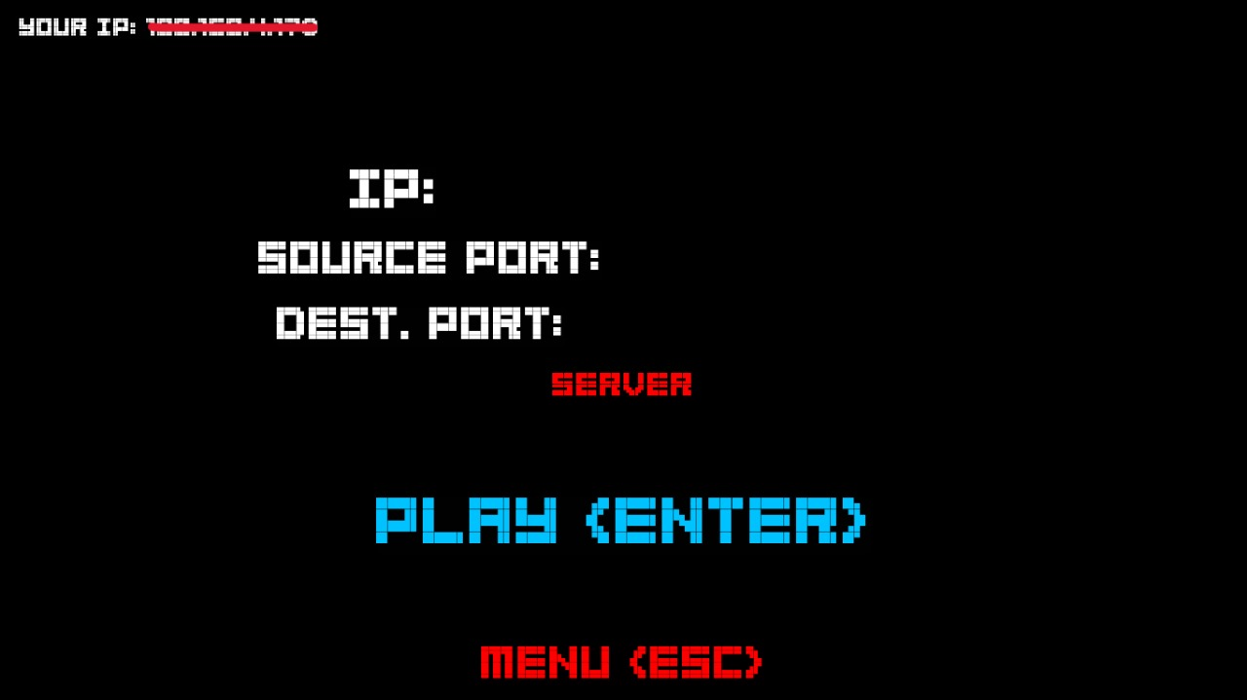

**Future Scope**

The present iteration of our top-down shooter game, a testament to our achievements, serves as a launching pad for future aspirations that extend far beyond the confines of the current landscape. In envisioning the future, we recognize that the key to elevating the gaming experience lies in a strategic roadmap of improvements and expansions.

One avenue for enhancement involves the thoughtful incorporation of new levels, each meticulously crafted to present increasing challenges and complexities. This strategic addition is designed to cater to the diverse skill levels of players, ensuring sustained engagement and fostering a palpable sense of progression within the game. It reflects our commitment to providing an enriched and evolving experience for our player community.

Furthermore, the horizon of future possibilities extends to the broadening accessibility of our game. The prospect of making it compatible with a myriad of platforms holds the potential to open doors to a wider audience. Enabling players to seamlessly engage with our game across various devices aligns with our overarching commitment to ensuring that the joy of our top-notch shooter with a Pacman theme reaches and resonates with as many gaming enthusiasts as possible.

In conclusion, the current milestone is not a static endpoint but a dynamic stepping stone toward continuous evolution and refinement. Our top-down shooter game, born from the harmonious synergy of Java and Pacman, beckons players into a realm where the past gracefully meets the present.

As we reflect on the accomplishments of one chapter, the door swings open to a future teeming with endless gaming possibilities and the enduring spirit of innovation that propels us forward.

The journey remains an ever-unfolding narrative, and the future promises new levels of excitement, accessibility, and ground-breaking experiences for players who embark on this captivating adventure with us.

As we embark on this journey of innovation and limitless potential, we remain steadfast in our dedication to fostering a sense of community. Community-driven events, tournaments, and collaborative projects will become integral components of our roadmap, ensuring that the bonds formed within our gaming ecosystem grow stronger with each passing milestone.

In conclusion, the present success of our top-down shooter game serves as a launchpad not only for its own continued evolution but also for the broader narrative of gaming innovation. The pages of our story are far from being fully written; each new chapter unfolds with the promise of excitement, accessibility, and groundbreaking experiences, inviting players to join us on a captivating adventure that knows no bounds. As we navigate this dynamic landscape, fueled by the spirit of innovation, the future is poised to deliver an unparalleled gaming experience, setting the stage for a new era of digital entertainment.

In summary, the journey ahead is characterized by a commitment to innovation, community engagement, environmental consciousness, educational enrichment, global accessibility, and unparalleled transparency. As we continue to push the boundaries of gaming, the future promises not only groundbreaking experiences within the game itself but also a broader impact that resonates far beyond the pixels on the screen. Together, we embark on an extraordinary adventure, where each player's story is interwoven with the ever-expanding tapestry of our dynamic and evolving gaming universe.

# Chapter 5

# References

1. Loh, C. S. (2012). *Information Trails: In-Process Assessment of Game-Based Learning, In Assessment in Game Based Learning, 123-144*. Springer.

2. Chang, CS., Chung, CH. & Chang, J.A. (2020); Influence of problem-based learning games on effective computer programming learning in higher education. Education Tech Research Dev 68.

3. Ali, A., Abderrahim, S., Majid, B.. (2019); Adapted model for creating the learning games of the java language; International IEEE Conference on Intelligent Systems and Advanced Computing Sciences (ISACS’19).

4.Mathrani, A., Christian, S., & Ponder-Sutton, A. (2016). PlayIT: Game Based Learning Approach for Teaching Programming Concepts. *Journal of Educational Technology & Society, 19*(2), 5–17.

5. Lang, D. & Tantan, O.C. & Boughzala, I.. (2016); "Learning business process management through serious games : feedbacks on the usage of INNOV8," Post-Print hal-02375809, HAL.

6. Brito, M. A., & de Sá-Soares, F. (2014). Assessment frequency in introductory computer programming disciplines. *Computers in Human Behavior, 30*, 623–628.

7. Game Development and Java Programming:

- Brackeen, D. (2007). "Developing Games in Java." Apress.

ISBN-978-0-596-00730-0

9. Pacman and Classic Game Design:Duggan, M. (2005). "Creating Games: Mechanics, Content, and Technology." A K Peters/CRC Press. - Mitchell, D. (2009). "The Art of Game Design: A Book of Lenses." CRC Press.ISBN- 978-0123694966